Simple Hash Function (Hash Function 1 / Custom Bitwise Hash)
Aim
To implement a custom lightweight modular arithmetic/bitwise hash function (Hash Function 1) for demonstrating data fingerprinting.
Algorithm
- Initialize Hash Variable: Set a prime starting value (e.g., hash = 5381).
- Iterate Input: Loop through each character of the input string.
- Mix Bits: Update the hash value using bit shifting and addition operations (e.g., hash = ((hash << 5) + hash) + c [DJB2 style hash variant]).
- Format Output: Return the resulting integer value modulus a boundary or print it directly as an integer/hex checksum.
Program:
#include <stdio.h>

unsigned long custom_hash(const char *str) {
unsigned long hash = 5381;
int c;
while ((c = *str++)) {
// Bitwise operations: hash * 33 + c
hash = ((hash << 5) + hash) + c;
}
return hash;
}

int main() {
char string[] = "CryptographyLab";

unsigned long hashResult = custom_hash(string);

printf("--- CUSTOM HASH FUNCTION 1 EXPERIMENT ---\n");
printf("Input String: %s\n", string);
printf("Computed Hash Value (Decimal): %lu\n", hashResult);
printf("Computed Hash Value (Hex): 0x%lx\n", hashResult);

return 0;
}
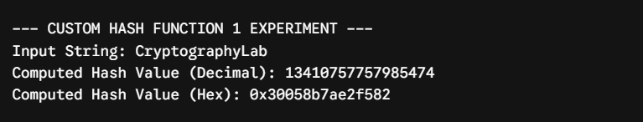

Result:
thus the program has successfully executed and compiled with perfect output.

